**Project: *Flood Monitoring and Early Warning System***

**Design:**

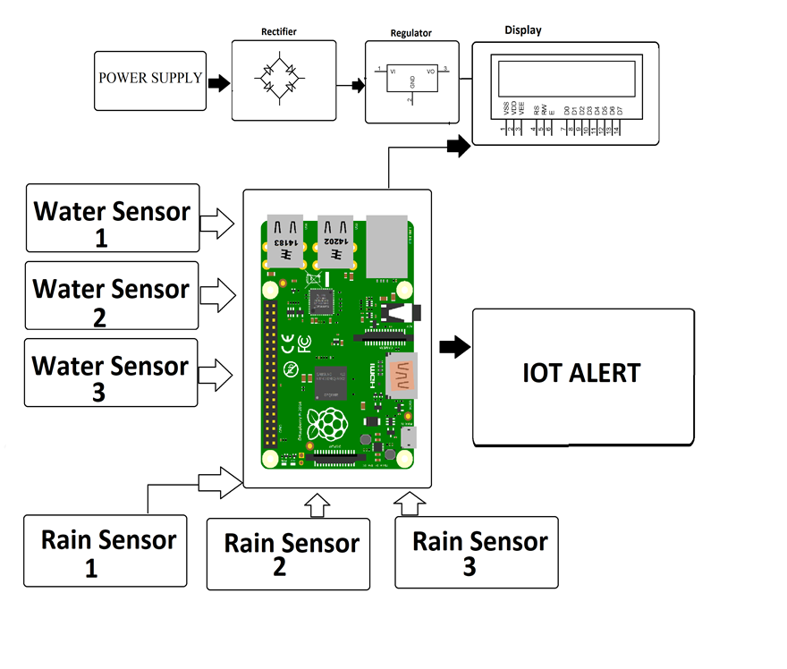

* In this system we make use of a Arduino with water sensors, rain sensors to predict flood and alert respective authorities and sound instant alarm in nearby villages to instantly transmit information about possible floods using IOT.
* The water sensors are used to measure water level of 3 different locations. Also 3 different rain sensors are used to measure rain level of those 3 areas. These sensors provide information over the IOT.
* On detection of conditions of flooding the system predicts the amount of time it would take to flood in a particular area and alerts the villages/areas that could be affected by it. The system also calculates the time it would take for flood to reach them and provides a time to people so that they can evacuate accordingly.

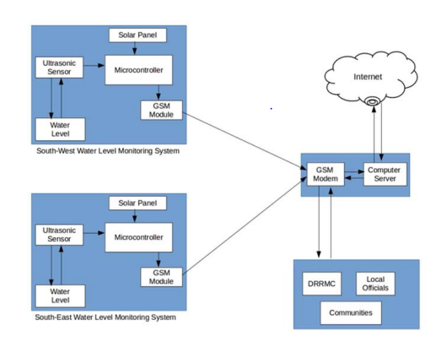

* The two monitoring devices are composed of Ultrasonic sensor to measure the distance of the water level, Arduino micro-controller that process the signal from the sensor, GSM module to send the data or information from the micro-controller to the computer server and a power source using Solar Panel, Regulator and Battery.
* Once a sensor is triggered, an output signal will be relayed to the micro-controller which serves as a switch that triggers the connected GSM module to send an alert message or water level status to another GSM modem connected to a computer server.
* Then, the developed program installed in the computer server will interpret and analyze the message received then automatically send a text message to the concern agencies’ numbers stored in a database.
* Also, the developed program will then automatically relay the alert message or status by uploading to the developed website.